A Comparison between US and China Energy Consumption

As China has risen to the world’s second largest economy in 2010. We will compare the disparities between the two top economies: U.S. and China.

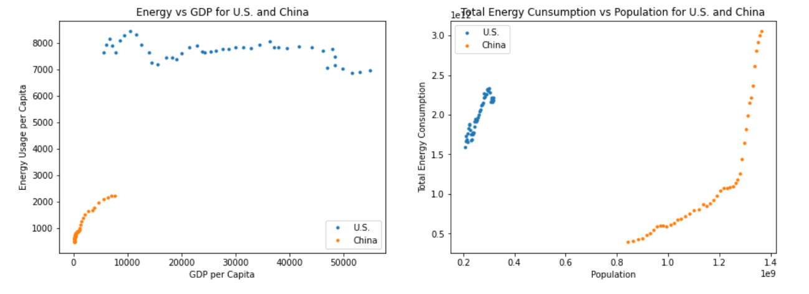
The plot GDP vs Energy Consumption on the left, we see that American people are very far ahead of China in term of GDP and energy consumption. Since 1970 – 2014 (where observing data are being considered here), American people seems to taper off their appetite for energy consumption and even decreased it slightly. On the other hand, China improved both their energy consumption and GDP. However, the improvement is not equal, Chinese energy consumption grew faster than GDP did.

America has its energy consumption per capita way ahead of China’s, however, in term of total energy consumption, China already surpassed America (plot on the right). It is due to the many times larger the population of China compared to America’s.

As the rise of China economy, comes the rise of its energy consumption. We will use FBProphet to build a forecast model how the state of energy consumption look like if the level of China matches U.S.

To conform with the requirements by the method, we will build a DataFrame with two columns: ‘ds’ will be the year (1971 – 2014), and ‘y’ will be the difference between U.S. and China energy consumption (per capita)

delta_df= pd.DataFrame()
delta_df['ds'] = US.index
delta_df['y'] = US.Energy.values - China.Energy.values
delta_df.ds = delta_df.ds.astype(str)

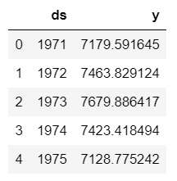
We will have a DataFrame:

Building the forecast model:

delta_prophet = fbprophet.Prophet(changepoint_prior_scale=0.15)
delta_prophet.fit(delta_df)
delta_forecast = delta_prophet.make_future_dataframe(periods=25, freq='Y')
delta_forecast = delta_prophet.predict(delta_forecast)

In this model, we adjusted the ‘periods’ a few time to have the forecast up to where the difference become Zero, where the energy consumptions of China and U.S. are equal.

In the new DataFrame created by Fpprophet, the last column ‘yhat’ will be the predicted future values. We can retrieve the year that the difference becomes Zero. The command below will list all the years that yhat values lower than Zero:

delta_forecast.loc[(delta_forecast.yhat<=0)].ds


We can go one year above it, Prophet will forecast that by 2035, China level of energy consumption will match the level of America.

We will through the similar procedures to forecast China population in 2035. We will find that China may reach a population of 1.5 billion (1.501692e+09). At this point, China alone will consume as much energy as 2.27 times the amount of energy China consumed in the whole 2014 and 0.5 times the entire world’s consumption of the same (including China itself):

(cn_forecast.loc[65].yhat*cn_eng_forecast.loc[65].yhat) /
energy.loc['World']['2014']*population.loc['World']['2014']

(cn_forecast.loc[65].yhat*cn_eng_forecast.loc[65].yhat) / (China.loc[2014].Energy*China.loc[2014].Population)

which will equal to 6.9 trillions kg of oil equivalent per year (2035). A quick lookup will state that it is 136kg/barrel. Thus, by 2035, China alone will consume about 51 billions of barrels of oil per year.

With the assumption that countries maintain their 2019 oil production level, which is at 100 millions barrels a day (IEA, https://www.eia.gov/outlooks/steo/report/global_oil.php ), it would take 510 days (1.4 year) to supply enough oil for China for 2035.

